**Team :**

Rahul Reddy Yerva

Class Id : 46

Rupesh Sai Ram Doddala

Class Id : 10

Anusha Jasthi

Class Id : 13

**Question 1:**

**Introduction:** Python program that computes the net amount of a bank account based a transaction log from console input. **Objective:** Gives net amount of a bank account

**Work Flow:**

Initially reads the account number and then initilize the amount to 0, Then it asks the user to enter the appropriate options whether to Deposit or Withdraw. if we it is Deposit we are adding the deposit amount to initial amount and if the option is Withdraw we defferentiate the amount from the present amount in account. If the option is End Transaction we get the final output of transacion.

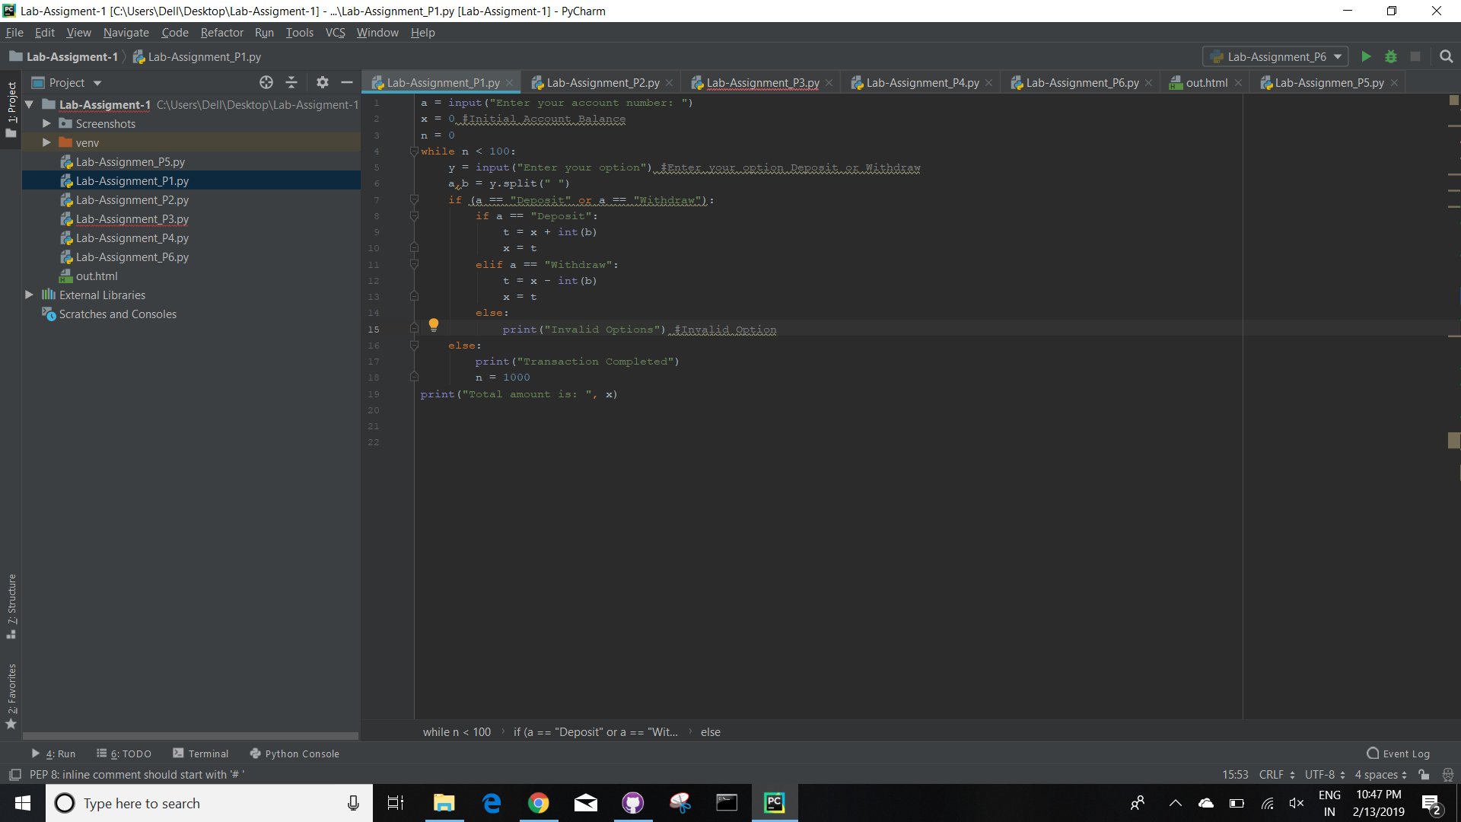

**Conclusion:**

Hence, the net amount can be displayed as follows.

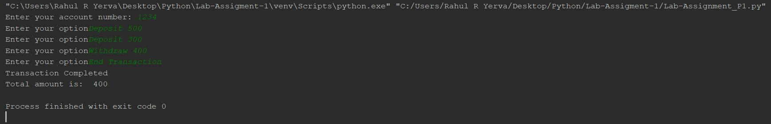

**Question 2:**

**Introduction:**

Create a dictionary with keys as names and values as list of (subjects, marks) in sorted order

**Objective:**

Here we create a dictionary with keys as names and values as list of attributes like subject and marks, and then sorting them in sorted order.

**Approaches:**

Here we are taking inputs such as name , subjects and marks, adding names in the tuple and adding subjects and marks in the subtuple. Finally we convert the list to dictionary with names as keys and subjects and marks as values in a sorted manner.

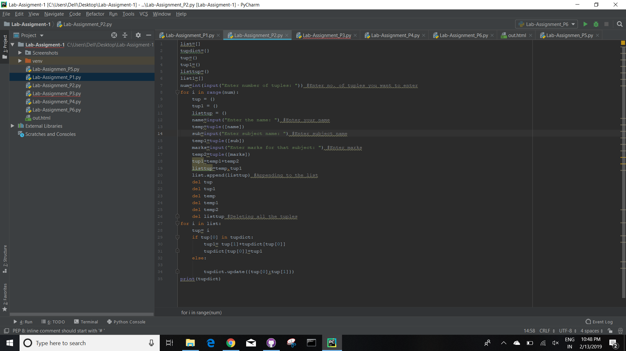

**Conclusion:**

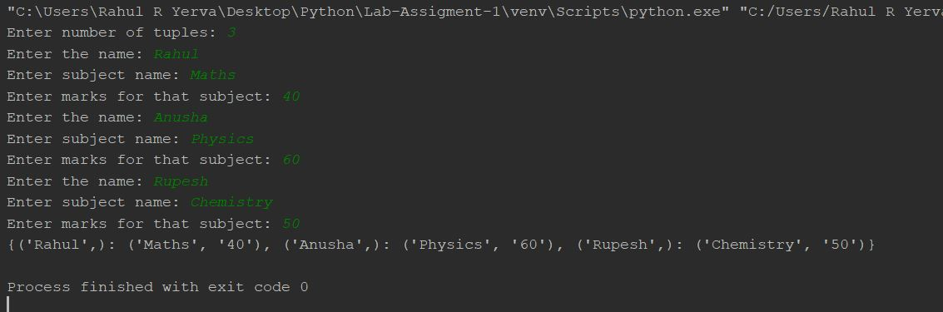

**Question 3:**

**Introduction:**

Consider a list of students attending class python and another list of students attending class Web Application take input for list of students from the console.

**Objective:**

Display the list of students who attend both the classes and also who are not common in both the classes.

**Approaches:** Here we are creating two sets python and webapp, and for displaying the students who are attending both the classes we use & operator , for displaying the students who are not common in both the classes by using ^ operator.

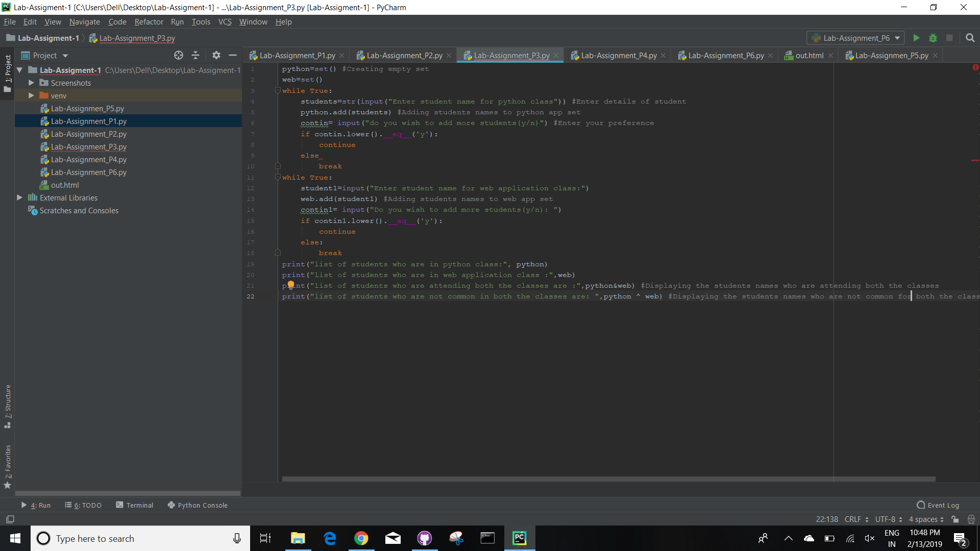

**Conclusion:**

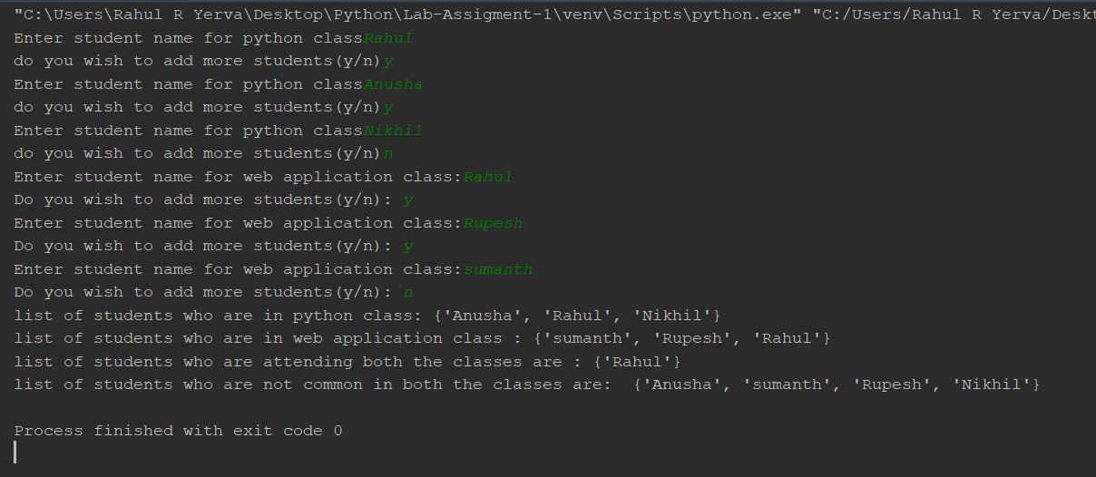

**Question 4:**

**Introduction:**

Read a string and find a longest sub string provided no character should repeat and also return the sub string's size.

**Objective:**

Gives the biggest sub string with its length.

**Approaches:**

Here we are importing copy library initially and creating two empty lists substring and substring2. we take each letter from the string and if there are any repetetions on the string we calculate the length of the string from then and further similar operation is performed on remaining strings. Finally the biggest sub string is displayed.

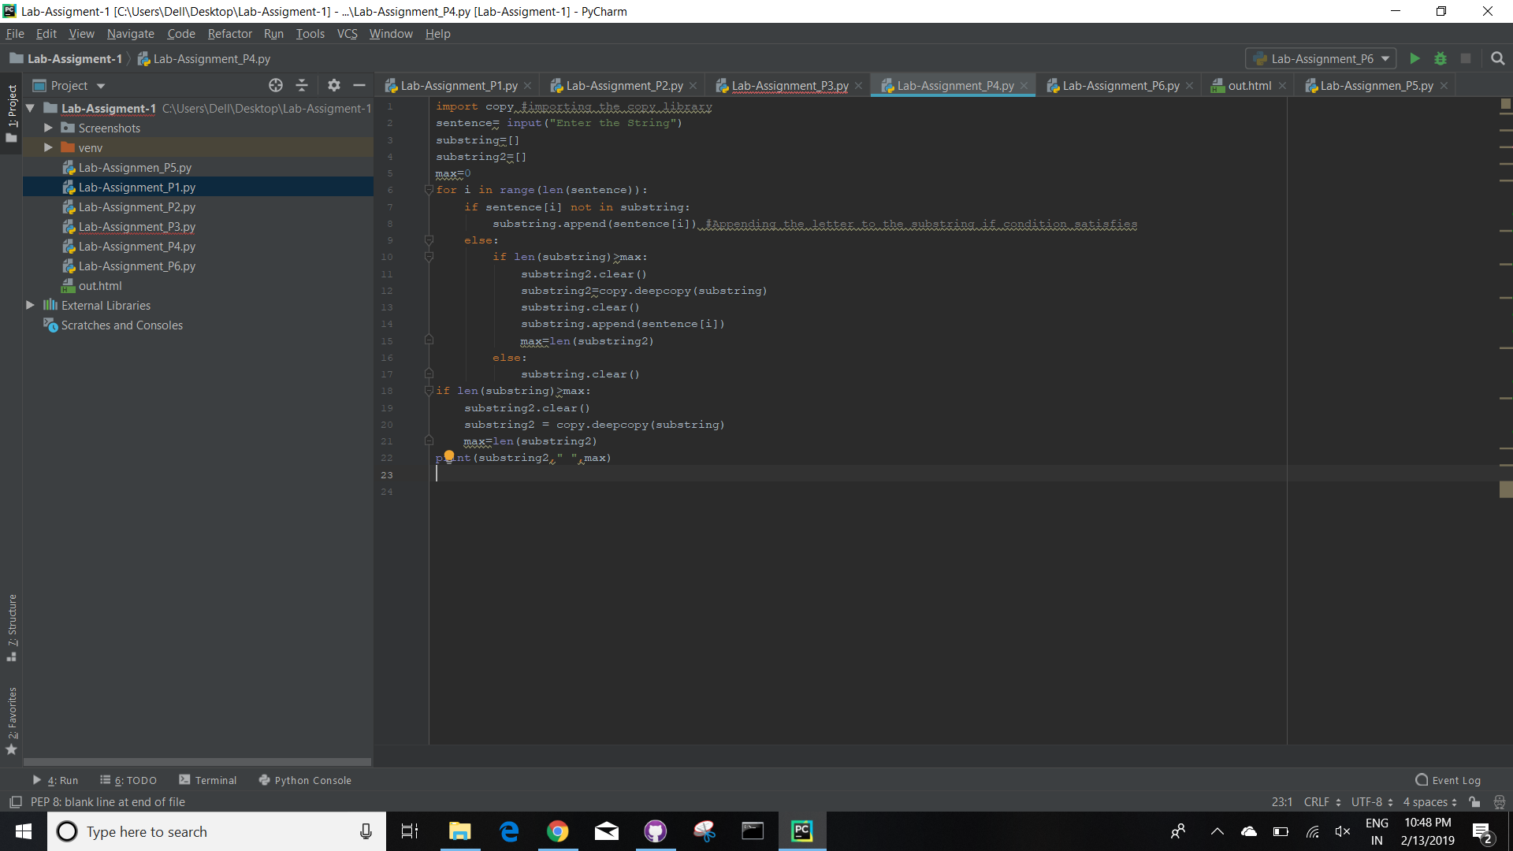. **Conclusion:**

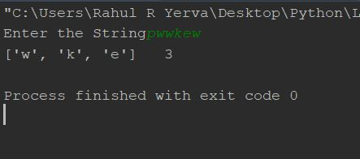

**Question 5:**

**Introduction:**

Creating a python program for airline booking reservation system, which displays information about passenger details,ticket details etc.

**Objective:** To create a python program for airline booking reservation system.

**Approaches:** Here we create five classes such as person. flight, employee , ticket and passenger. we use inheritence concepts to display the details of the passenger related.

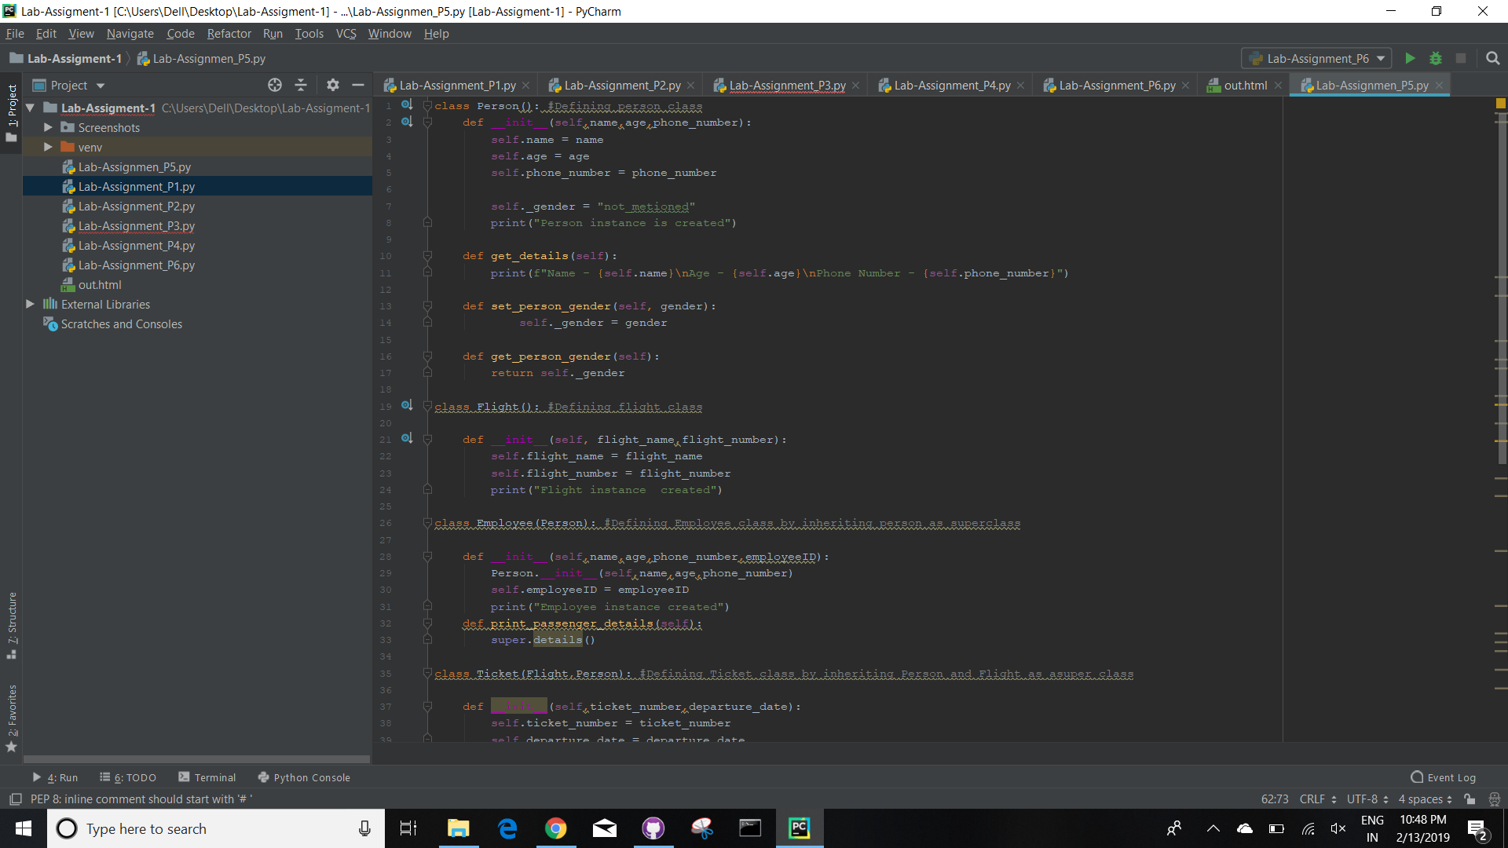

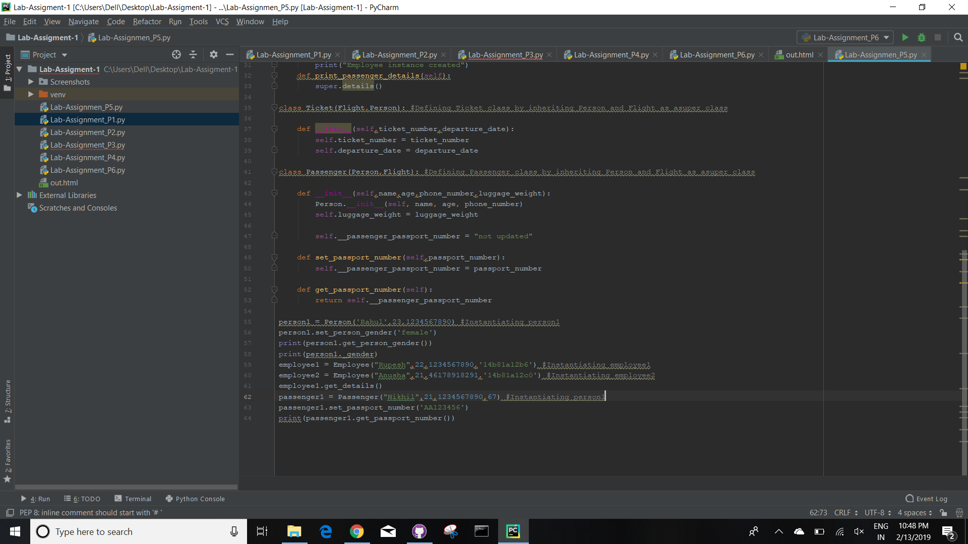

**Conclusion:**

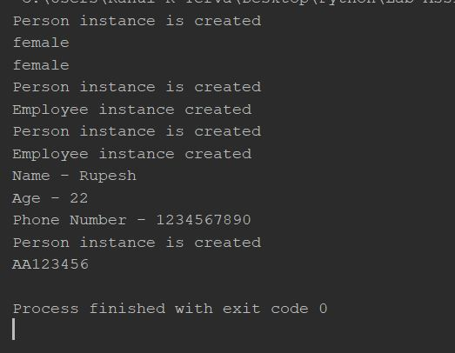

**Question 6:**

**Introduction:**

Writing the code for requesting libraries and reading a link and getting the information from the link.

**Objective:**

Reads the input link and gives the data it will be saved in a file.

**Approaches:**

Initially requests the libraries and imports the beautifulsoap and then reads the html link and using a parser and displays the required data.

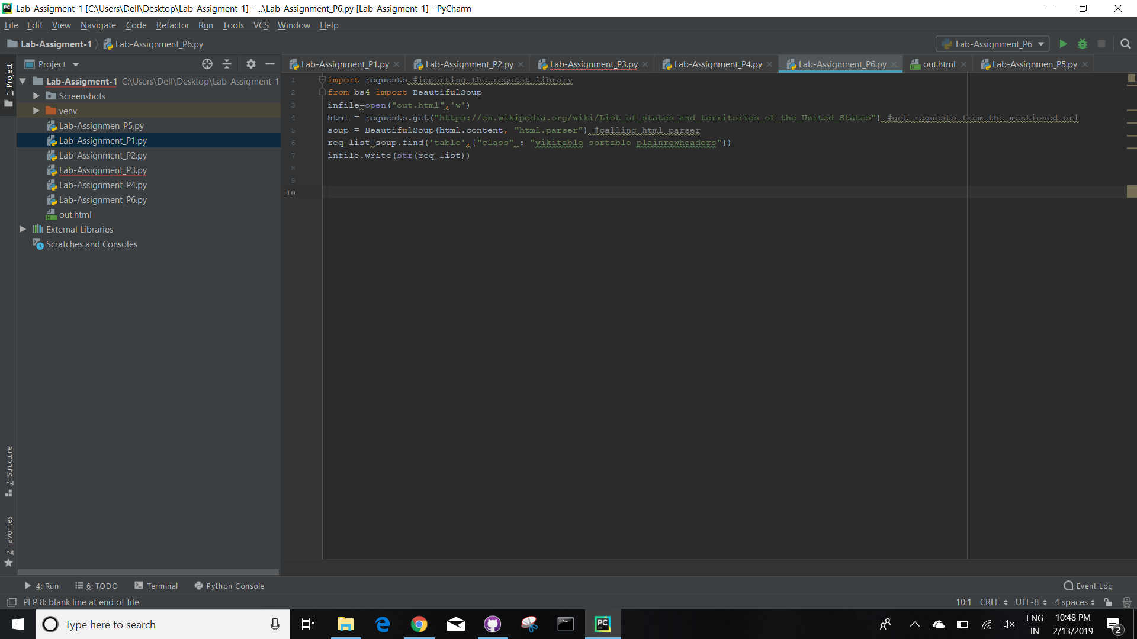

**Conclusion:**

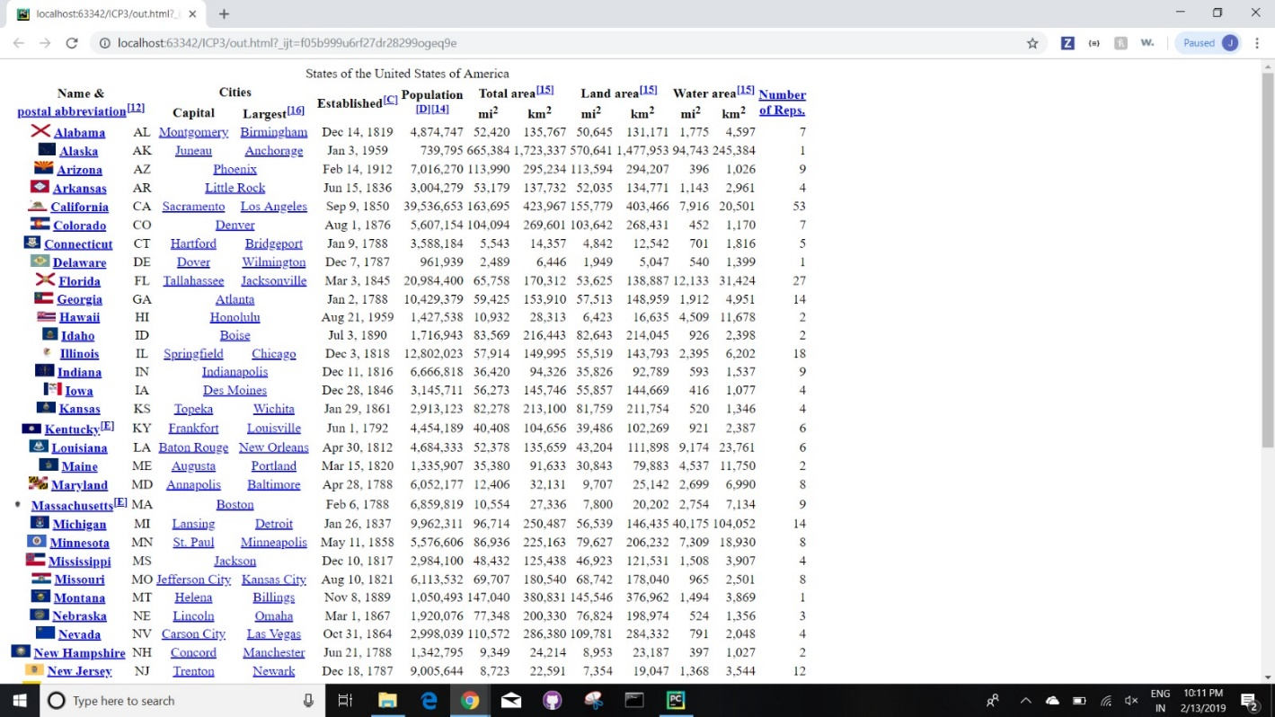

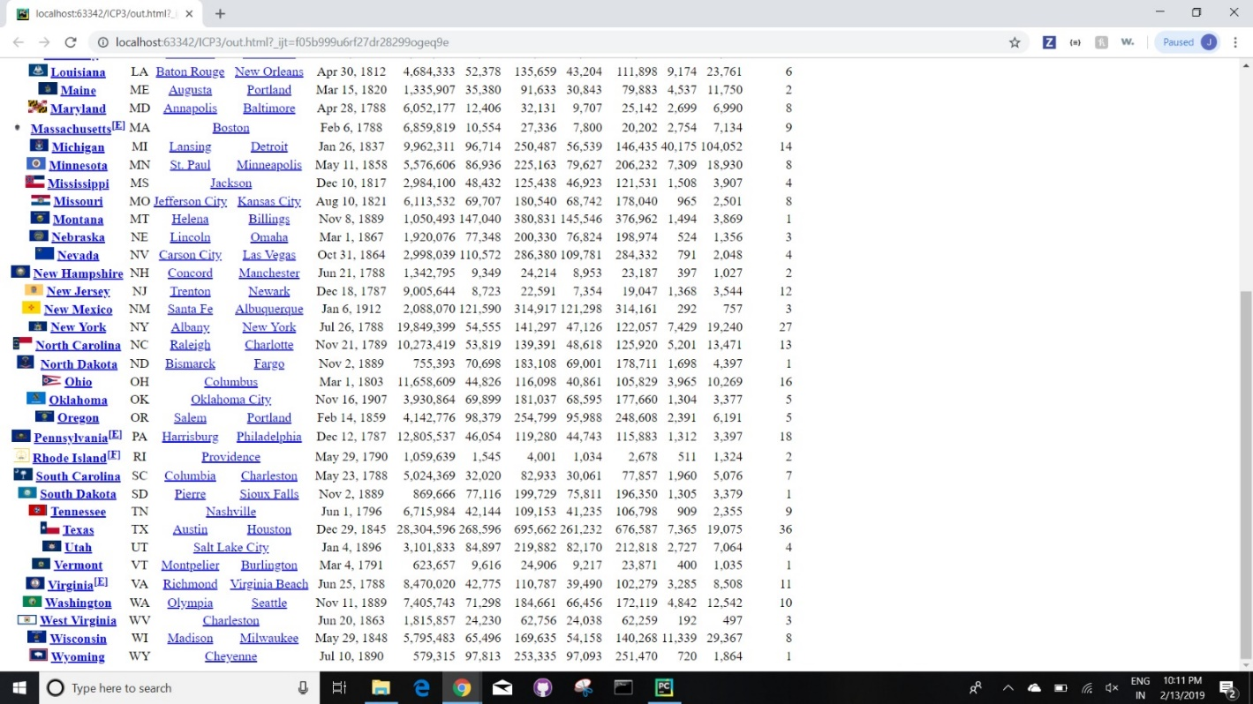

Github Link:

Youtube Link: